
JIM JUNIOR SCHOOL - KIBUKU
“To Excel Is Our Aim”
Tel (+256)787643047 or (+256)756072716
Email: schooljimjunior@gmail.com

END OF TERM ONE EXAMINATIONS 2023
PRIMARY SIX
MATHEMATICS
DURATION: 2HRS 30 MIN
Name ____________________________________________________
SECTION A (40MARKS)
1. | Add 47 + 21
2. | Solve for y: 2y + 4 = 10
3. | Describe the shaded region in the venn diagram below  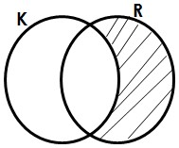

4. | Find the next two numbers in the sequence  0, 2, 4, 6, ____, ____
5. | Add: $\frac{2}{5} + \frac{1}{5}$
6. | Work out: 4 +⁺ 7
7. | Peter walked a distance of 4km from home to school. What distance did he cover in metres?
8. | Find the distance covered by a bus travelling at a speed of 6okm/hr for 2hrs.

9. | What number has been expanded to give  4000 + 600 + 70 + 4
10. | Find the value of yin the diagram below  2  y  40  0
11. | A radio was bought from a shop at sh.40,000 and sold at sh.36,450. Calculate the loss made
12. | Shade 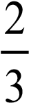 of the diagram below.

13. | If set k={a,b,c} how many subsets has set k
14. | Draw tallies to represent 27
15. | Work out 6 - 2 + 4
16. | Round off 245 to the nearest tens
17. | Find the LCM of 4 and 6.
18. | If picture represents 5 balls. Draw pictures to represent 45 balls.
19. | Express 0.4 as a common fraction in its simplest form.
20. | How many lines of folding symmetry has the figure below

SECTION B (60 Marks)

21.  (a)  (i) | Study the Venn diagram below and use it to answer questions that follow  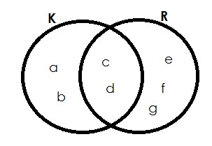  List elements of:-  K = (1mark)
(ii) | K R (1mark)

(b) | Find n (K – R) (2marks)
22.  (a) | Racheal wrote the following digits on different cards; 6, 7 and 9  Write down the smallest number written using the digits (1mark)
(b) | Write down the largest numeral written using the digits. (1mark)
(c) | What is the sum of the largest and the smallest number written  (1mark)
23a) | Using a ruler, a pencil and a pair of compasses only, construct a regular hexagon using a radius of 3.5cm. (3marks)

(b) | Calculate the perimeter of the above hexagon (2marks)
24.  (a) | In a class of 72 children,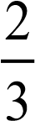 are boys and the rest are girls.  What fraction of the class are girls? (2marks)
(b)(i) | Find the number of boys in the class (2marks)
(ii) | Girls in the class (2marks)
25(a) | Add: 2 2 3_{five}  + 1 4_{five}  (2marks)
(b) | Change 123_{five} to base ten (3marks)

26.  (a)  (i) | Study the number line below and use it to answer the questions that follow.  a  -  5  -  4  -  3  -  2  -  1  0  1  2  3  4  5  6  c  b  Write down the integers indicated by letters (1mark each) a ______________________
(ii) | b ______________________
(iii) | c ______________________
(b) | Write a mathematical statement for the above information (2marks)
27.  (a) | A bus travelling at a speed of 40km/hr covered a distance of 240km.  Find the time taken by the bus. (2marks)

(b) | A mathematical lesson started at 8:40am and ended at 10:30am. How  long was the lesson (2marks)
28.  (a)  (i) | Use the venn diagram below to answer questions that follow  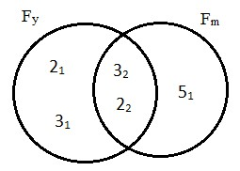  Find the value of; (1mark) y
(ii) | m (1mark)
(b) | Find the GCF of y and m (2marks)

(c) | Find the LCM of y and m (2marks)
29.  (a) | Kate bought the following items from the supermarket  - 2kg of sugar at sh.5000 per kg  - 2 mathematical sets at shs.4000  - 4 pens at shs. 500 each  - 3kg of rice at shs.4000 per kg  What was Kate’s total expenditure? (4marks)
(b) | If Kate had 2 notes of twenty thousand shillings, how much did she take as change

30.  (i) | Solve and find the value of y  y + 6 = 11 (2marks)
(ii) | $$\frac{2k}{5}=6$$
31.  (a) | Study the diagram below and use it to answer questions that follow    3  m  4  m  5  m  6m  Find the area of the outside figure. (2marks)

(b) | Find the area of the inside figure (2marks)
(c) | Work out the area of the shaded part (1mark)
32.  (i) | The following marks were scored by a P.6 pupil in the beginning of term one examination  50, 40, 75, 50, 45  Find the range of the marks
(ii) | Find the median mark
(iii) | Work out the mean  END

